Personal Living Habits
habit:
something that you do often and regularly, sometimes without knowing that you are doing it

Reaction - Chain
A habit is the product of a reaction chain. Something triggers us and the response is the habit we created for that trigger. A habit shouldn’t be seen as a behaviour, but rather a process that creates a behaviour.

For example:
When you wake up in the morning you go to the bathroom to brush your teeth.
(Trigger: You wake up, Response: You go and brush your teeth, Reward: clean teeth)
When you are stressed, you smoke a cigarette.
(Trigger: Stress, Response: smoke a cigarette, Reward: temporary stress-release)
Putting on a seatbelt after getting into the car.
(Trigger: getting into the car, Response: putting on a seatbelt, Reward: safety)

Good & Bad Habits
A lot of people swear by creating healthy habits to minimise making decisions, thus being more efficient, and avoiding unhealthy choices. Therefore, there are tons of guides and tips for creating healthy habits to improve your life. Some of them are simpler and some of them harder to build.
- getting 8 hours of sleep every night
- drinking enough water
- eating a balanced diet
- meditation or practising mindfulness
- exercise
There are a lot of habits that are considered unhealthy and even more people that want to break these habits.
- smoking
- over- or undereating
- not exercising
- being on your phone too much
- procrastination

Building & Breaking a Habit
First, building or breaking a habit takes a lot of time and there might be setbacks, but you need to push through until you don’t need to think about the action you take.
The first thing you need is a specific goal and a habit that gets you closer to that goal. As we already established a habit needs a trigger or cue, so you need a cue that triggers that habit you want to build. The easiest way to introduce a habit is to either connect it to an already existing habit (stacking habits) or an activity.
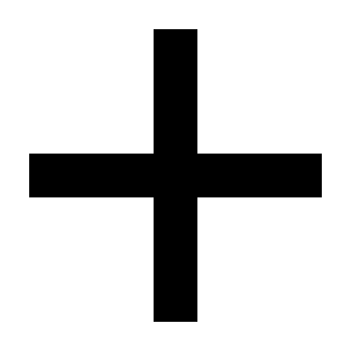
Example for a goal:

I will read more this month.
I will read a book for 15 minutes daily at 6 am on the couch.
Breaking a habit is as tricky as building a new one.
To start, you have to identify the habit you want to quit. Next, you need to identify the triggers and try to minimise their occurrence. Still, the habit provided you with a reward, and therefore you need to replace it with something different that gives you the same kind of reward.

Environment vs Motivation
A habit is effective as you do it subconsciously. Therefore, there is no decision process and no need to rely on motivation to do something.
What makes a habit even more effective is an environment where there are a lot of triggers for good habits and no triggers for bad ones.
Example: Putting your phone in another room while working

